Final Project Proposal

**Overview**

The Marvel Cinematic Universe (MCU) currently includes films and television programs spanning over fifteen years, two film studios, and six phases. The goal of the website is to organize relevant information regarding the MCU and its upcoming projects. By organizing this information in a fun and relevant way it will reduce Information overload and increase fan engagement.

**Audience**

The audience for this website will be fans of the MCU as well as anyone who is interesting about the MCU in a fun and engaging way.

**Functions**

The application will appear as a file cabinet, where the user can open and retrieve files. There would be a drawer for previous projects, current (this year)’s projects, and future planned projects. Within those files you would be able to view a document about the specific project you’re interested in. This is a grandiose plan, so I’m not sure if I’ll be able to pull it off. BUT I will try my very best to achieve something like this.

**Wireframes**

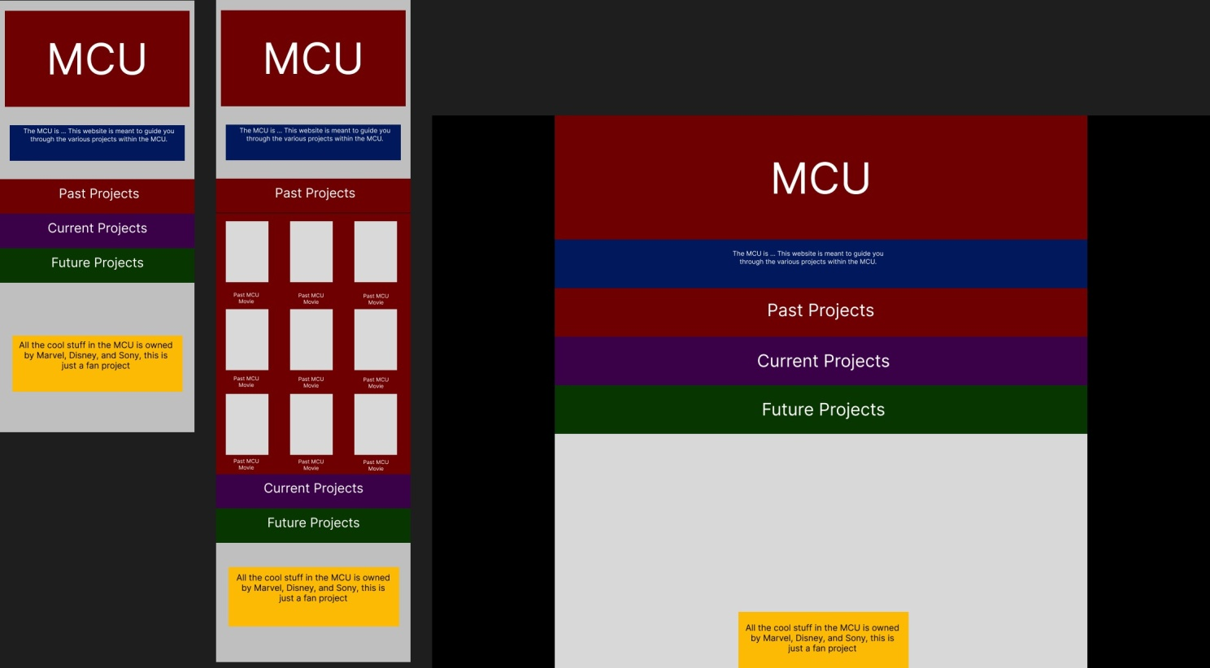

**Initial Module List**

Utils.mjs – This would include any methods being used widely.  
Past.mjs – This would include any methods to generate the past MCU projects.

Current.mjs – This would include any methods to generate any current MCU projects.

Future.mjs – This would include any methods to generate any future MCU projects.

**Colors/Typography-**

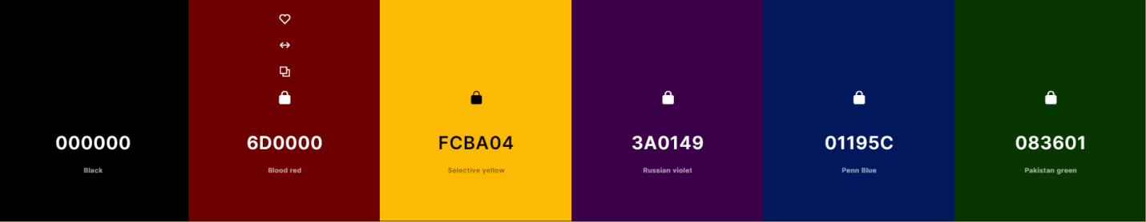

Amatic SC - https://fonts.google.com/specimen/Amatic+SC?stroke=Sans+Serif&subset=latin&preview.text=Upcoming%20Projects



Special Elite - <https://fonts.google.com/specimen/Special+Elite?preview.text=Release%20Date:%202023-02-17>



Josefin Sans - https://fonts.google.com/specimen/Josefin+Sans?stroke=Sans+Serif&vfonly=true&preview.text=A%20font%20for%20long%20paragraphs 

**Mile markers**

Feb 7

Get Bare bones mobile site up. Should include some CSS and Bare Bones desktop site should be working, also make some CSS. Research the API more in depth and see if it is robust enough or if I should generate my own database to pull information from.

Feb 9

Refine sections. Create logic that determines if a project is current or future.

Dynamically insert images

Feb 12

Create Files that pull from API,

Animations of files opening

**Trello Board**

https://trello.com/invite/b/lmABdadR/ATTI03495528c832d43f3a5998b1e71629ce68ED77E2/mcu-workflow